EXERCISE: 11
DATE: 20.11.2020

AIM:
To write a Python program to find the greatest common divisor (GCD) of two integers using recursion.
PROGRAM:
def gcd(a,b):
if(b==0):
return a
else:
return gcd(b,a%b)
a = int(input("Enter first number: "))
b = int(input("Enter second number: "))
GCD = gcd(a,b)
print("GCD is: ")
print(GCD)
LINK:
http://103.53.53.18/mod/vpl/forms/submissionview.php?id=326&userid=1757
OUTPUT:
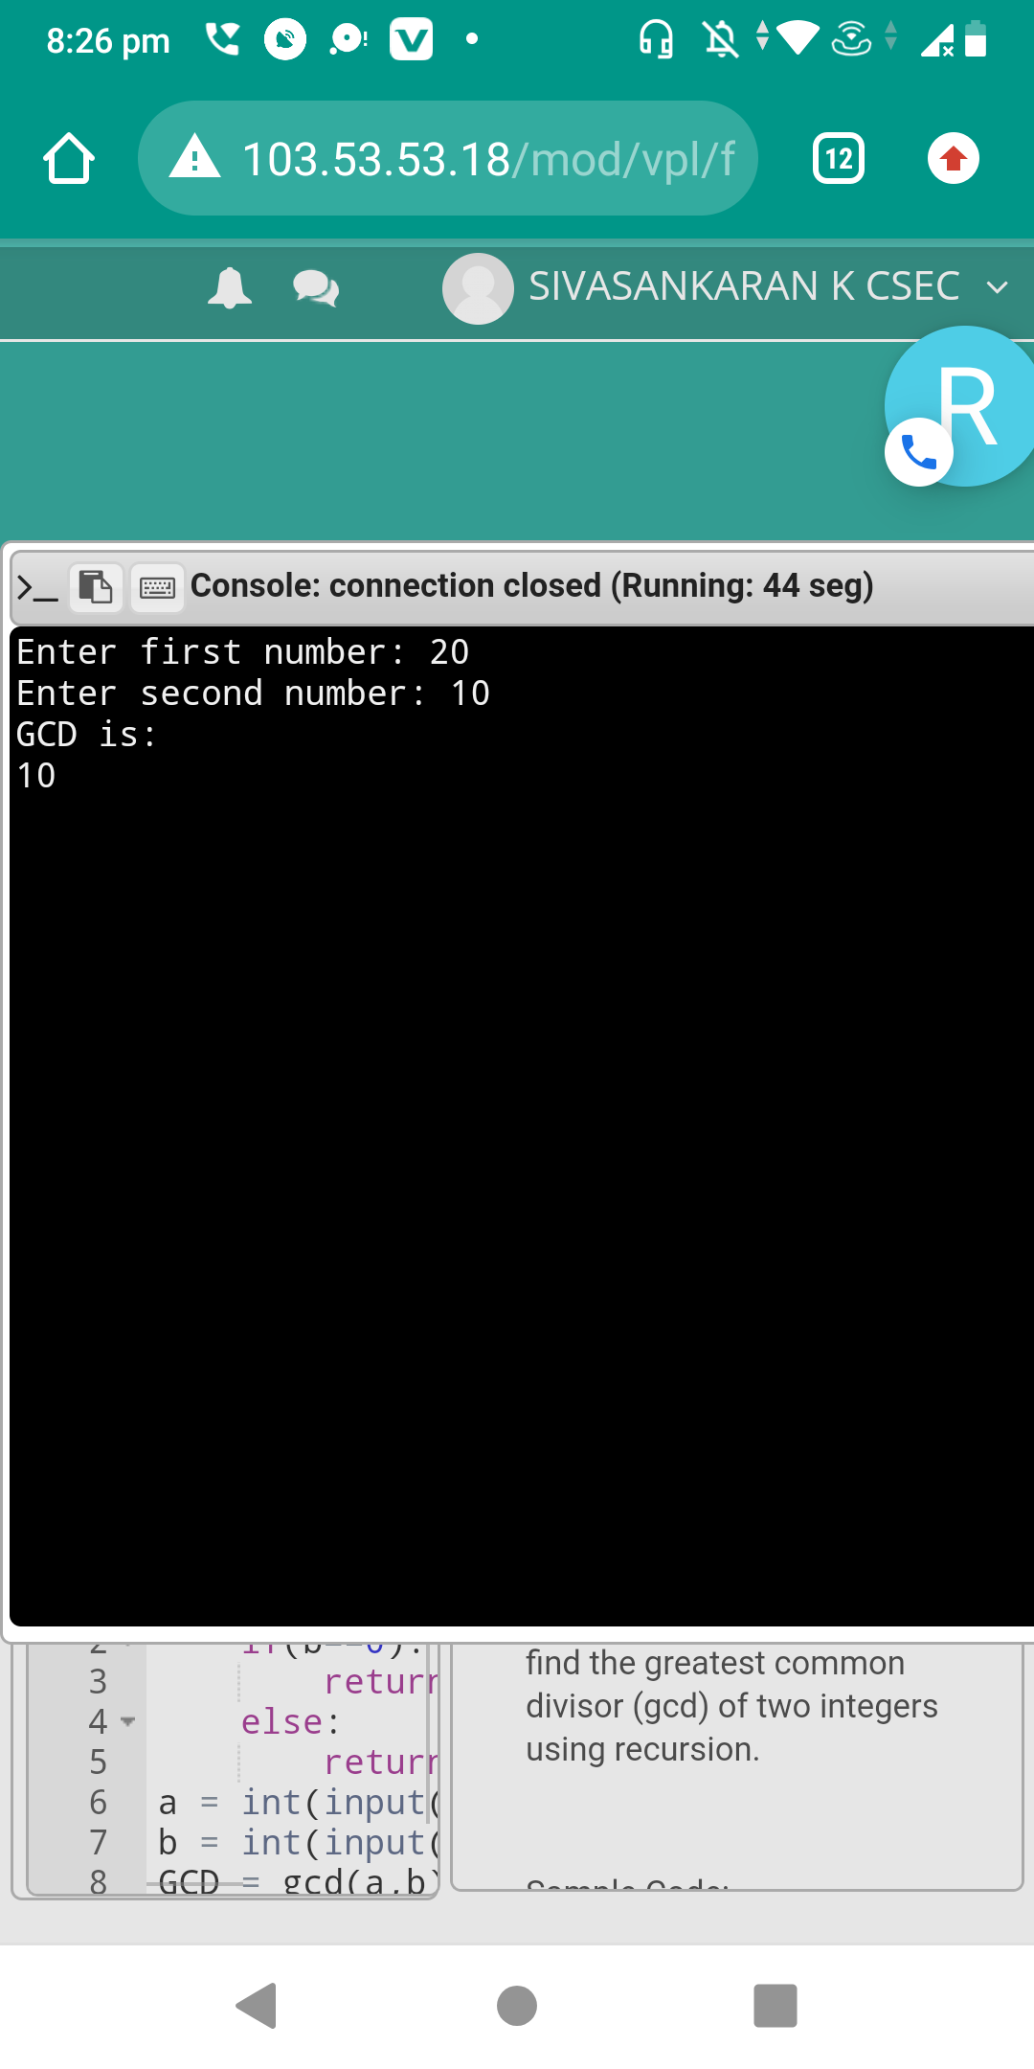
RESULT:

The output of the program is verified successfully.

